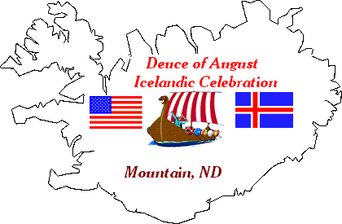
Fjalla Blað
Seventeenth Edition 2009

Mountain Chat
“Hvað er svo glatt
sem góðra vina fundur?“

I. C. A.
P.O. Box 63
Mountain, ND 58262-0063
“What is as joyful as a
gathering of good friends?“

labration

Gleðileg Jól og Farsælt Nýtt Ár
Merry Christmas and Happy New Year

Fjalla Blað
Icelandic Communities Association
POB 63
Mountain, ND 58262-0063
USA

Return Service Requested

NON PROFIT ORG.
US POSTAGE
PAID
MOUNTAIN, ND 58262
PERMIT # 4

----------------------------

Gearing up for the 2010

111th Annual Deuce of August Icelandic Celebration
July 30th, 31st-August 1st
Mountain, ND

THOUGHT YOU’D LIKE TO KNOW:
Our Celebration will always be held on the weekend preceding the first Monday in August!
This enables visitors to also attend the Islendingadagurinn in Gimli on the first Monday in August.
2010-111th Deuce of August Celebration--Friday, Saturday, & Sunday—July 30th, 31st--August 1st
2010 is the 132nd anniversary of the settlement of the Icelandic Communities in Northeastern North Dakota!

Celebration future dates Thanks David Hillman
(2011-7/29 thru7/31) (2012-8/3 thru 8/5) (2013-8/2 thru 8/4) (2014-8/1 thru 8/3) (2015-7/31 thru 8/2)

President, Curtis Olafson-13041 84th St.NE-Edinburg,ND 58227-Ph. 701-993-8240-E-Mail-colafson@polarcomm.com
Vice-President, Leslie Geir-8517 Hwy. 32-Edinburg,ND 58227-Ph. 701-993-8367-E-Mail-lesgr@polarcomm.com
Secretary, Loretta Bernhoft-P.O. Box 204-Mountain,ND 58262-Ph. 701-993-8282-E-Mail-bernhoft@polarcomm.com
Treasurer, Bjork Olafson-13041 84th St.NE-Edinburg,ND 58227-Ph. 701-993-8240-E-Mail-bjork@polarcomm.com
Editor, Duane Halldorson-P.O. Box 064-Mountain, ND 58262-Ph. 701-993-8116-E-Mail-halldor3@polarcomm.com

The 2010 Membership drive is underway.
Membership runs from Jan. thru Dec.
$10.00 per person
Any Membership payment that arrives after November 15th of that year will be applied to the following year.

NOTE: Membership dues are not tax deductible, but any contributions over and above that are tax deductible.
ICA has 501 c 3 (tax-exempt non-profit) status from the Internal Revenue Service.

NOTE: You may pay your dues in advance.
“Please note on your check which year’s dues you are paying”

2009 Deuce of August
$1000 & $500 ICA MONEY RAFFLE.
2009 Winners were
$1000 - Arvid Knutson - Park River, ND - - $500 - Sherry Hettwer - Munich, ND

Our Raffle Ticket Super Salesman for 2009 was Arvid Knutson.
Thanks Arvid for all your hard work.

2010- $1000 & $500 Raffle Tickets well be available in June
Contact Duane or Jeanne Halldorson-701-993-8116--halldor3@polarcomm.com

MCCCC letter here-page 3
President’s letter on back-Page 4

President’s Message

Curtis Olafson

Greetings to all of our friends and supporters. The 110th Deuce of August Celebration is now in the history books and what a weekend we had! But before I reflect on the success of the Celebration weekend, I would like to first talk about the most exciting news in a long time for the Icelandic Communities Association and the entire area around Mountain. After years of very hard work on the part of many people in our community, we are thrilled to announce that we have broken ground for the new Mountain Community Center and construction is underway! This new 14,000 square foot facility will incorporate the community needs under one roof in a very efficient building utilizing geothermal heating and cooling. Included in the building will be the community café, fire department, quick response, a banquet room with seating space for 300, several offices, including a new and much needed office for our Icelandic Communities Association and leaseable space for businesses. Please see the attached letter for more information on the current status of the project and visit the project website at www.mountainnd.com for ongoing updates as the project progresses. It is our hope that we can schedule a dedication ceremony in a completed building by the Celebration weekend for the 111th Deuce of August in 2010!
Now back to the news about the 110th Deuce of August. Many people, myself included, thought that this past Celebration was the most successful Celebration since the 100th in 1999, and that is saying something as all the Celebrations that we have had since 1999 have been great events. We had excellent attendance at most every event and the level of enthusiasm and interest in our rich heritage, history and culture has never been higher. One of the most unique and popular events in that regard has been the Genealogy Center, which has been operating for a few years now and is growing in popularity every year. This was an idea and a concept originated by members of the Icelandic Communities Association and has now expanded to include a “Cousins Across the Ocean” project. Our Celebration also enjoys broad support because we incorporate a variety of events which appeal to those who may not have an interest in heritage. As the official site of the North Dakota State Tractor and Pickup pulling contest and with our very popular street dances, those with other interests also find something fun and interesting at the Deuce of August Celebration.
One of the concerns we had had as we prepared for the Celebration was what effect the economic downturn might have on how many guests we could expect from Iceland. We were very pleased to have had one of the busiest years ever in hosting guests from Iceland, with several groups visiting during the Celebration weekend and other tour groups visiting from May through October. We have word that 4 groups are already booked for next year.
I would like to sincerely thank everyone from the community and beyond who pitch in to make the Celebration so enjoyable and successful. Many of you who come back home to enjoy the weekend also roll up your sleeves and help us out and it is greatly appreciated and we couldn’t do it without you!
We have already begun planning for the 111th Deuce of August, and we received some great news recently which will certainly get us started for next year in a big way. We have been approved for a $5,000 grant from the North Dakota Tourism Department! If you have been watching the news lately, you know that tourism is doing very well in North Dakota and we are proud to play a small part in that success in our state. We would like to thank the Tourism Department for their support of the 2010 Celebration. Mark your calendar now for the 111th Deuce of August to be held July 30th, 31st, and August 1st, 2010. Watch for more information on the 2010 Celebration in a later newsletter, and check out our website at www.august2nd.com to learn more as we continue to make our plans for the 111th Deuce of August. I look forward to seeing you there!

"My best wishes to you and yours for a Happy Holiday season and a healthy and prosperous New Year”

Genealogy
George Freeman & Pam Furstenau

2009 was another good year at the Genealogy Center. Pam Furstenau and George Freeman are gaining more experience each year and adding more data to their files. We are still working on requests made at the Deuce.
This, the 6th year, the Genealogy Center presented something very special. It was the Alfred G Hanson woodworking exhibit. His work created a lot of attention and everyone marvels at his talent for making such fine examples of wood working. One of the best pieces was an oak table made from 100 year old wood taken from Alfred’s grandfather’s homestead cabin. The table tilts and swivels and is a beautiful example of his handiwork. Susan Sigurdson Powers deserves the credit for bringing Alfred’s exhibit to the Genealogy Center.
Susan also came up with the idea of the “Mash road signs” at the celebration. The signs tell us how far we are from Reykjavík, Gimli, etc. The signs provide a good backdrop for scenic pictures and many people at the celebration took advantage of it.
In the second year our “Cousins Across the Ocean“ project worked its wonders again. Meeting at the Heritage Program Saturday afternoon were two sets of cousins. Rósa Jónsdóttir of Iceland met many second cousins including Shirley & Robert Olgeirson, Ken Halldorson, and Richard Bjornson. Margrét Þorsteinsdóttir of Iceland met Paul & Cecil Sigurdson of Edinburg and Georgine Goodman Tofteland of West Fargo.
Pam Furstenau & George Freeman along with Hálfdan Helgason of Iceland did the cousins research for tour groups in May, June, and July. Many cousins met in Canada. We received help this year from Doreen Marston of Florida and Jayne Paradis of Winnipeg.
Next year we want to introduce a new idea. We want to create a visitors register for Icelandic Canadian and Icelandic American visitors coming to the Deuce of August. There is a remote chance that registered visitors from Canada or US may have Icelandic cousins visiting the Deuce of August Celebration from Iceland and everyone will see who is visiting which will make for more reunions of friends and relatives. To register as a visitor at the Deuce of August 2010 please send an email to gfreeman@gra.midco.net.
Naomi Myrdal of Edinburg has an idea that we should make big maps of US, Canada, and Iceland and at the Deuce of August people can put pins on the map to show where they came from. It is a wonderful idea. We will put the map in a prominent place for people to see and use.

Vikur Church Gets Makeover
Loretta Bernhoft

The Vikur Church is currently under a renovation. The Vikur Society and LCW have made plans to have new carpet installed throughout the church. This is another huge undertaking for this little community. The floor and carpet in the center aisle had begun to buckle and roll creating a hazardous walkway. In addition, a pipe in the basement broke causing water damage on that level. The cost of the project is substantial and creates a new challenge for our church. With some insurance proceeds and funds from the annual LCW salad luncheon and quilt raffle, the seed money for the project is in place. Fund raising will continue and the next fund raising event will be a basket auction in December. We are requesting that anyone who may want to help with the project make plans to donate a basket of their choice and/or plan to attend the auction. For more information, please call Susie Hanson (701) 993-8204 or Loretta Bernhoft (701) 993-2828 or (701) 331-0638.

Celebration This & That
Susan (Sigurdson) Powers

Well, the little village of Mountain did it again! The 110th 2nd of August Celebration went off without a hitch! The weather was cool and breezy—perfect for the parade and tractor pulls. Mountain is normally pretty quiet on an average day, but it starts hopping during the 2nd of August Celebration! It is a homecoming of sorts for many people from across the country and the Icelandic Klub of Fargo-Moorhead was well represented there this year, too! Al & Arlys Bjornson and Russ and Lois Bekkerus were there to attend a Bjornson family reunion (descendants of M. F. Bjornson, the first mayor of Mountain). Kris Bjornson, elder of the Bjornson clan, was the parade Grand Marshall; Kris is the grandson of M.F. Bjornson. Fred L. Bjornson came for the reunion too; Fred lives in Iowa and is a 64 year member of the Mountain American Legion. There was another Bjornson gathering in Mountain, too— Fred & Marilyn Bjornson came from Arizona. Their daughter Denise Bjornson had a book signing on Saturday; she has authored the novel Defining Grey. Richard and Janyce Bjornson served as tour leaders for the bus tours and Richard helped set up the book signing for Denise. Denise was stationed at the old Vikur church site and was busy signing books when I stopped in to say Hi. Pam & Jeff Furstenau stopped in to see the woodworking display by Alfred Hanson (it was impressive) and brought daughter and son-in-law, Macy & Jay to see it too. Pam worked with George Freeman to host the Genealogy Center. Their Cousins Across the Ocean project introduced a couple of members of the choir from Iceland to ‘new’ cousins here in the US. They also helped other people find their Icelandic ancestry and even helped a Norwegian or two in their genealogy quest. They do a great job and always have a project in the works! (they’re working on a cemetery project now—it is amazing!) Gary & Connie Olson made the trip from Fargo and enjoyed the woodworking exhibit, too. Linda Palmer from Wahpeton and Clare Hauck from Moorhead were making the rounds—they both reported that the Heritage trip to Iceland in June was great! Evie and Ken Holand came from Minot and joined their daughters Jane Valente from New Jersey and Jen Nelson (of Fargo) and the grandkids in taking in the celebration. I didn’t get to meet him, but heard that Jen had little Arlo John there to attend his first Mountain celebration—he probably won’t remember it much (he was only 2 weeks old!), but I’m sure there are pictures to show him someday! Kristi Olafson came from Plymouth, MN and helped Mom Judy Olafson and crew get the tables ready for the fellowship dinner and later helped with ticket sales at the tractor pull. Marino & Doris Steinolfson had their usual front row seats to watch the parade and celebration. They enjoyed visits from the ’kids’, Cheryl McEwen,,Margaret Dahl, and Gene Steinolfson in the week before the celebration. Ken & Karen Halldorson came from Bismarck, ND; Ken met a cousin from Iceland courtesy of the Cousins Project. Larry and Twila Nicholson were there, too—Larry was on Main with his Iceland themed T’s and polos. His shop was set up beside the Akra Snack Shack, home of the Abrahamson clan—Karen Abrahamson, Jana Abrahamson & Andrew Sherman, Andrea Abrhamson and daughter, Audriana. As always they had great Icelandic food (they served 164 dozen kleinur on Saturday!!!) and enjoyed a visit from the dignitaries from Iceland, too. Sigrun Sigurdson enjoyed the parade and attended the fellowship supper. Past member Sandy Wright of Utah was home for the celebration. Loretta Bernhoft was host to the dignitaries from Iceland and made sure the Foreign Minister Össur Skarpéðinsson and Arny Erla Sveinsbjörnsdóttir made it to Gimli for Íslendíngadagurin. Steingrimur Steinolfson and family were there and had an entry in the parade promoting Steingrimur’s Travels to Iceland. Richard Steinolfson and Ron and Aileen Steinolfson Luethe took part in the gathering too. Saw Tim Ness, and heard that Kathleen was there too. Robert Olgeirson rode in the parade float for the Heritage Tour participants; new member Marge Busch spearheaded the campaign to get a float for the parade. Robert and sister, Shirley Olgeirson hosted the bus tours at the Big Yellow House (homestead of G. B. Olgeirson); Shirley coordinates the bus tours and keeps the buses from running each other off the gravel roads. Tim and Susan Sigurdson Powers were there—Tim got Blake Laxdal and friends involved in getting the flags posted each day, Susan took photos of as many of the goings-on that she could (did you know that the parade had 90 entries???) and even caught Lon & Diane Volrath floating around the dance floor at the Old Time Dance. Darlene Mattingly and daughter Dyana and cousins from Iceland made the rounds and stopped at the Thingvalla memorial. Three of the Magnusson sisters, Thorey Green, Leola Larson, and Shirley Wild were there and headed up west on Sunday afternoon to attend the annual heritage service at Fjalla Church (I bet they sat in ‘their pew’ again—the family’s usual seating place for Sunday services while they were growing up). Duane Geir brought his fancy red convertible for the Show N Shine and led the parade with the Foreign Minister. Greg and Renata Selzer baptized little Gunnar Gregory at the Sunday church service. “continued”
Elaine Thorfinnson Laxdal stopped in to see the Genealogy Center (in the home formerly owned by Lynn and Eleanor Thorfinnson). Susan & Gary Atwood brought Aunt Rose Gudmundson to see Alfred Hanson’s woodworking exhibit and visit with friends and ‘cousins’ at every turn. I like Rose’s way of greeting folks in Mountain—give a hug and a kiss, then find out who they are!! It’s bound to be a relative or an old friend!! Magnus Olafson welcomed everyone at the Heritage program and did a great job as always. Carissa Thorlakson took part in the celebration indirectly—she was on the postcard promoting the Iceland Expo at the 2010 Scandinavian Hjemkomst Festival. (The photo was taking at Skogarfoss.). June Bjornson enjoyed the parade and visiting around town, too. Norma Nason was busy entertaining relatives (bet she had brown bread to offer to them!!) in the days prior to the celebration. John & Jacki Lawson took a break from their projects at the Eirikson farm to come in to watch the parade. John’s sister Norma Ruble was visiting from Oregon and joined them, too.
You know…..with all those Icelandic Klub members that were in Mountain for the celebration….we should have had an Icelandic Klub meeting!!!!!!!

K. N. Who??*
For the past number of years, I’ve served as the on-site host at the Thingvalla Lutheran Church Memorial for the bus tours during the 2nd of August celebration weekend. I’ve watched as the buses unload with the tour groups from Iceland and the people take in the interpretive panels, the prairie garden, the cemetery and statue. I’ve taken photos for some and answered some questions. At some point in the stop, everyone gravitates towards the panel and monument to K.N. Julius and then to the modest tombstone marking K.N.’s final resting place just inside the cemetery gate. If Jonas Thor is leading the tour, out comes a book of K.N’s poetry and the people silence their Icelandic chatter and listen attentively. Often they sing a song to K.N. and inevitably drink a toast in his honor and share a bit of Brennivin with him. Their fondness for this poet is obvious; many of them can quote his poetry from memory and take great pride in being able to do so.
Every year I’ve marveled at how much they know about him and his poetry and how little I know, even though I’ve lived in the same area that he lived and walked past the tombstone hundreds of times through the years. I wondered how an Icelander ended up with the name Julius (didn’t’ sound Icelandic to me!). I knew he was a poet and he lived a little north of the churchyard at the Geir farm. I’d even read a few of his poems that had been translated, but it took an old issue of The Icelandic Canadian to help me understand this fascination with K.N. Julius a little bit more. Thanks to permission from the folks at The Icelandic Canadian, some of that info is available to all. To those, who are well versed in the subject move on to the next article. If you’re like me and have finally reached a point in life where you realize that there’s more to the story and you´re ready to take it in, read on.
“Kristján Níels Jónsson was born the son of a blacksmith on April 7, 1860 in Akureyri, Iceland. His mother died when he was 14 years old and he went with to live with his brother, Davið Kristjásson. He lived there until he was eighteen, when he decided to set off for America. Upon arrival in America, his name was changed to Kristján Níels Júlíus. At the same time, he adopted the pen name K. N.—pronounced ‘cow-N’ and written in Icelandic as Káinn. His first year in the new world was spent in Winnipeg, Manitoba. He spent a few years in Duluth, Minnesota. In 1893, he moved to Pembina County, North Dakota and in the fall of 1894, he settled at Mountain with the Geir family. There he volunteered his services to the widow Anna Geir who needed a hand in running her farm. He made himself at home there, tending the milk cows, fetching water, and cutting firewood. K.N. also worked for the local funeral home as a grave digger and he was also known to be a brick-layer. K.N. spent the last forty years of his life on the Geir farm where he was like one of the family and died there of a stroke on October 25, 1936.
K.N never received any formal education in Iceland or in America. This may be due to the fact that he could not afford schooling here or abroad, or due to the fact that there were few elementary schools in Iceland and by the time he reached America he was too old to go to school. Rather, K.N. was self-taught, for he read as much Icelandic and American literature as he could find.
Iceland´s rich literary heritage undoubtedly contributed to K.N.‘s love of poetry. He became well-read in the literature written in English. He was, in effect, a product of two cultures--Iceland and America. Today, only a few hundred thousand people in the world can understand Icelandic. They are the only ones who can truly appreciate K.N.´s poetry in it‘s original form.
Coming from another country provided K.N. with a dual vision that gave him a down-to earth objectivity and sincerity that ultimately became the backbone of his poetry. K.N. composed poems about subjects that were most familiar to him in his daily life. One can assume that farm life played a great part in the moulding of his character. Many more themes are apparent in his poetry and include farm animals, liquor and drinking, religion and children.
K.N. is famous for invoking irony and tongue in cheek sarcasm into his ditties. Although several sources note that K.N. appreciated honesty and frankness, this did not stop him from composing the following poem about a party. It is humorous when the background details are known, and is a great example of K.N.’s surprise and playful endings.

August Second Annar Ágúst
Many left in a drunken sail Margur þaðaan fullur fór
Everywhere flows beer and ale freyddi á skalum malt og bjór
Whiskey? No one lacked a bit brennivin þar brast ei neinn,
‘Cause Sveinn and Dori were selling it. Þvi báðir seldu, Dóri og Sveinn.
Women served their coffee swill; Kvennfólk var með kaffisull
Men ranted speeches at their will karlmenn fluttu ræðubull
There was singing, there was dance. Þar var söngur, þar var dans
There was I and Reverend Hans. Þar var ég og sera Hans.

It sounds like a wild party and K.N. has taken great delight in saying Reverend Hans was with him at the wild scene. To get the full sting of his words you must know that Reverend Hans Thorgrimsen was one of the most highly respected ministers in the pioneer days, and you must know that he was dead against drinking. In truth he was not at the party, and when he first read the poem, he is said to have exploded!
But K. N. did achieve the effect he wanted. It was not unlike him to bait ministers, most of whom he found too self righteous and sure of themselves.”

Contributed by Susan Sigurdson Powers
*Printed with permission. Excerpts from K. N., Who? By Tammy Einarson, The Icelandic Canadian, Summer 1994.
The Icelandic Canadian is about to change its name to Icelandic Connections. It is $40 US and International for 4 issues. The mailing address is: Icelandic Connections, Box 1156, Gimli MB R0C 1B0.
The magazine is produced by a volunteer organization, which for over 67 years have put the magazine together. They welcome any writings and/or translations from any Icelandic writings that would deal with Icelandic communities present and past. They also welcome creative writing and poetry. They want to be a spot where aspiring writers can get their work into print.

BORG PIONEER MEMORIAL HOME AUXILIARY ANNUAL BAZAAR

On Saturday, September 19, 2009, the Borg Auxiliary, held its annual Bazaar and Bake Sale and it was a great success. The raffle winners were as follows: The “Between Friends Quilt by Eldean Newell was won by Amil Majerus, Aurora, Co (Norma Nason’s granddaughter); a crocheted doily by Joann Hardy won by Bernice Flanagan of the Edingurg General Store; and a china painted plate by Rosa Thorfinnson was won by Mary Lou Hartje, Hensel. Sherry Hannesson of Mountain, had the high bid in the silent auction for the afghan made by Vergel Ritter, Cavalier.

The great success of the bazaar was due to all the time, items, and baked goods donated by the Borg Auxiliary Members and many wonderful members of our community. And we also have to thank all the great shoppers who came and spent lots of their hard earned money. Thank you all.

Borg Celebrating 60 Years
Kathy Thorlakson

Borg Icelandic Old People’s Home opened its doors to serve the elderly in the Mountain community in 1949. The dedication of the new building was October 23, 1949.
In the last issue of the Fjalla Blad, Pam Fursteneau shared the history of Borg written by F. M. Einarson and Lyle Hoverson. The tickets shown in the accompanying photo bring a little of that history to life and focus on all those who have supported Borg through the donation of time and money. Community involvement was vital in the process of planning and construction, and the tickets show one of the ways that money was raised for Borg’s construction.

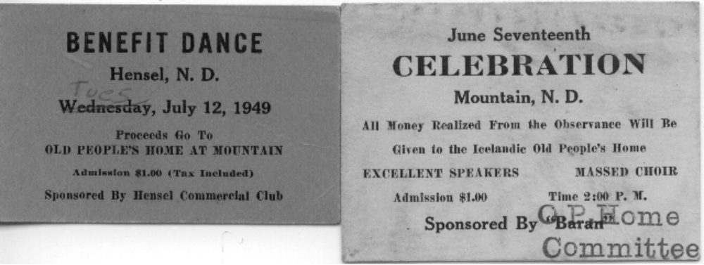

Though many things have changed in 60 years; including the name to Borg Pioneer Memorial Home, the support of our large community of friends has remained an important part of Borg’s continued success. Currently a fall fund drive supports ongoing projects. Last year’s fund drive was used to install Handicapped Accessible doors to the Ambulance entrance and to the patio which improved the lives of our residents and our staff. The fund drive for this year will be used to install a new Call Light system.
As we move forward into a new decade of service, we are grateful for the work of those who have served on the Board of Directors, for the members of the Borg Auxiliary, and for many good and faithful employees through the years. In visiting with people over the days of the celebration, many had fond memories of their first job at Borg. Many also commented on Christmas memories, visiting friends and family who resided at Borg, and the special people they came to know at Borg. Borg’s Mission Statement, “To provide excellent, quality care to the elderly with compassion” has served for 60 years and it will continue to guide Borg into the future.

2009 ICA Memberships

Abrahamson | Andrea
Abrahamson | Eric
Abrahamson | Jana
Abrahamson | Jonathan
Abrahamson | Karen (Hillman)
Abrahamson | Karie
Abrahamson | Karl
Akset | Orlin
Anderson | Duane & Emilía (Jónsdóttir)
Atwood | Gary & Sue (Herman)
Axelson | Cobie (Bjornson)
Baumgardner | Cindy (Stefanson)
Bekkerus | Lois
Benjaminson | George
Bernhoft | Neil & Melaine (Nordquist)
Bernhoft | Ryan & Stacie (Larson)
Bernhoft | Wayne & Loretta (Thorfinnson)
Biliske | Eleanor (Geir)
Bjornson | Fred L.
Bjornson | June
Bjornson | Richard & Janyce (Gudmundson)
Bleakley | Bud & Bev (Einarson)
Briese | Gloria
Busch | Karen (Thordarson)
Busch | Margaret (Thordarson)
Byron | Chris & Cecelia (Adams)
Byron | Chris & Julie
Byron | Eugene & Meredith
Carpenter | Eugene & Jackie (Thorfinnson)
Carson | Ted
Cataldi | Lavonne (Seinolfson)
Christianson | Arnold & Donna (McDonald)
Christianson | Jim
Cox | Joe & Gladys (Finnson)
Davidson | Ronald & Martha
Einarson | Betty (Hughes)
Einarson | Dennis
Fafnis | Reynis & Elizabeth
Finnson | Thord
Flanagan | Lynn & Celeste (Bernhoft)
Fredericksen | Ms. Alexis
Freeman | George
Freeman | Greg
Freeman | Megan
Furstenau | Jeff & Pam (Olafson)
Geir | Leslie
Gudmundson | Chad & Janna (Brandvold)
Gudmundson | Keith
Gudmundson | Kenneth
Gudmundson | Norman
Gudmundson | Rose
Halldorson | Barney
Halldorson | Dennis
Halldorson | Duane & Jeanne (Jacks)
Halldorson | John
Halldorson | Kenneth & Karen (Carlson)
Halldorson | Michael
Halldorson | Richard & Ellyn (Brown)
Hammer | Beverly
Heck | Scott
Heiser | Carrie (Einarson)
Helgisdóttir | Amanita M.
Helgoe | Lee & Viola (Halldorson)
Hemsher | Pandora (Byron)
Herzog | Douglas
Hillman | David
Hughes | Christine
Johannesson | Cory
Johnson | Bernice
Johnson | Dawn (Benjaminson)
Johnson | Jim & Marilyn (Halldorson)
Johnson | John & Darlene (Hunt)
Johnson | Lyle & Margie (Jonasson)
Johnson | Verna (Johnson)
Johnson | Victor & Dorothy
Jonasson | Esther (Baarstad)
Jonasson | Moritz & Lorraine (Walter)
Kenney | Darlene
Knutson | Arvid & Darlene (Bjornson)
Kristjanson | Alfred
Kristjanson | Sibbie & Emily
Lagen | Nicolette (Biliske)
Larson | Suzanne
Lorenzen | Margaret (Olgeirson)
Lowe | Jim & Erna
Machacek | Donald & Asta  (Bessie Hallgrimson)
Mathewson | Elin (Melsted)
Melsted | Waldemar & Ida (Dearinger)
Moore | Timothy & Sylvia
Morrison | Pat (Nason)
Muldoon | William & Janet(Goodman)
Myrdal | Donald & Lillian (Helgason) (Hall)
Myrdal | Rosemarie
Nason | Norma (Johnson)
Ness | Tim & Kathy
Neuhalfen | James
Nielsen | Einor
Nielsen | Linda
Northfield | Amy (Kristjanson)
Olafson | Anne
Olafson | Curtis & Björk (Eiriksdottir)
Olafson | Dean
Olafson | Doran
Olafson | Drew & Samantha (Swanson)
Olafson | Eugene
Olafson | Judith ( Sigurdson)
Olafson | Kristi
Olafson | Larry
Olafson | Magnus
Olafson | Robert M.
Olafson | Robert & Betty (McDonald)
Olafson | Roger & Marilyn (Olson)
Olgeirson | Robert
Olgeirson | Shirley J.
Paulson | Catherine
Peterson | Kris & Dorothy (Einarson)
Powers | Tim & Susan (Sigurdson)
Prien | Debbie (Halldorson)
Robinson | Dorothy (Moore)
Rollin | Leon & Mae (Heigaard)
Rosencrans | Beverly
Scheving | Anna (Bjarnason)
Schroeder | Theodore & Lorraine (Bjornson)
Selzer | Greg & Renata (Olafson)
Sigmar | Eric
Sigtryggsson | Louise (Seinolfson)
Sigurdson | Joe & MaryAnn
Sigurdson | Shirley Jo
Simundson | Marie (Byron)
Smith | Frederic & Linda (Stefanson)
Stanford | Dave & Cheri (Olafson)
Stanton | Lara K. (Kristjanson)
Steinberg | Audrey (Hillman)
Steinolfson | Marino & Doris (Goodman)
Thompson | Lawrine & Norma (Laxdal)
Thorfinnson | Rosa (Kristjanson)
Thorlacius | Ethel (Byron)
Tiffany | Norma (Asta Myrdal)
Timian | Carol (Christianson)
Troftgruben | Marilyn (Steinolfson)
Vatnsdal | Cindy
Vatnsdal | Gene & Judy
Vatnsdal | Rebecca
Volrath | Lon & Diane
Walski | Melissa
Walters | Forrest
Warmoth | Beatrice (Snydal)
Watson | Jo Ann (Geir)
Wessels | Doug & Lorraine (Johnson)
Wild | Lillian (Snydal)
Wild | Richard & Mary (Bjornson)
Wild | Shirley
Williams | Ramona (Bjarnason)
Williamson | Allan & Marvel (Kristjanson)
Wright | George & Sandra (Matthiasson)
Yost | Susan & Stephen

2009 Contributions

Atwood | Gary & Sue
Bernhoft | Wayne & Loretta
Biliske | Eleanor (Geir)
Byron | Chris & Julie
Christianson | Jim
Chuckwagon | Gunnar & Jeni's
Hammer | Ronald & Judy
Helgisdóttir | Amanita M.
Johnson | Margie
Lowe | Jim & Erna
Muldoon | Janet & William
Olafson | Larry
Otter Tail | Power Co.
Polar
Weberg | Doug
Wright | George & Sandra
Yost | Susan & Stephen

2009 Memorials

Paul | Benjaminson
Olafson | Judith
Mohagen | Jane (Benjaminson)
Johnson | Dawn (Benjaminson)
R. ‘Franny ‘ | Sigurdson Diaz
Sigurdson | Shirley Jo

2010 ICA memberships

Abrahamson | Andrea
Abrahamson | Eric
Abrahamson | Jana
Abrahamson | Jonathan
Abrahamson | Karen (Hillman)
Abrahamson | Karie
Abrahamson | Karl
Barrett | Tom & Cindy (Biliske)
Benjaminson | George
Biliski | Dennis & Sue
Bjornson | Fred L.
Bjornson | Richard & Janyce  (Gudmundson)
Bleakley | Bud & Bev (Einarson)
Cataldi | Lavonne (Seinolfson)
Davidson | Ronald & Martha
Flesher | Tudy (Snydal)
Furstenau | Jeff & Pam (Olafson)
Geir | Richard
Gudmundson | Chad & Janna (Brandvold)
Gudmundson | Kenneth
Halldorson | Barney
Heigaard | Kris
Helgoe | Lee & Viola  (Halldorson)
Herzog | Douglas
Hillman | David
Holand | Kenneth & Evelyn
Hughes | Christine
Kristjanson | Alfred
Machacek | Donald & Asta  (Bessie Hallgrimson)
Melsted | Waldemar & Ida (Dearinger)
Myrdal | Rosemarie
Olafson | Anne
Otto | Mick & Doris (Biliske)
Paulson | Gary
Sigmar | Eric
Sigtryggsson | Louise (Seinolfson)
Sigurdson | Shirley Jo
Simundson | Marie
Stanton | Lara K. (Kristjanson)
Thompson | Lawrine & Norma (Laxdal)
Thorlacius | Ethel (Byron)
Volrath | Lon & Diane
Wild | Richard & Mary (Bjornson)

2009 Tractor Pull Sponsors

Austfjord Construction (Cavalier)
Bernhoft Farms/NTB Seeds
Bjorneby Trucking
Bjornson Oil
Byron’s Bar (Mountain)-2009 & 2010
Cavalier Supply
Cenex (Edinburg)
Cenex (Lankin & Adams)
Cenex (Walhalla)
Choice Financial of Langdon & Walhalla
CHS Milton
Citizens State Bank (Edinburg)
Citizens State Bank (Lankin)
Citizens State Bank (Park River)
Citizens State Bank Midwest (Cavalier)
C-Store (Cavalier)
D & B Motors (Langdon)
Dakota Services
Farm Credit Services of Grafton
First United Bank
Hanson’s Auto & Implement (Grafton)
Heuchert/ Willow Creek Ranch
Hurtt Equipment
Langdon Implement / Roy Implement / Cavalier Equipment
Langdon Locker
Mayo Construction (Cavalier)
Napa (Cavalier)
Northdale Oil (Neche)
Northland Oil
Northstar Co-op (Cavalier)
Northstar Credit Union
Olafson Brothers
Park River Implement
Polar Communications
Readel Farms
Richard McKnight Insurance Co.
Samson Electric (Park River)
Schumacher & Son’s (Grafton)
Simplot (Walhalla & Langdon)
Swanson Motors (Cavalier)
Thorlackson Construction LLC (Cavalier)
United Valley Bank
Walhalla Coop (Walhalla)
Wells Fargo Bank

Thank you all for your support!

The 2010 I.C.A. Membership drive is underway.
Membership runs from Jan. thru Dec.
$10.00 per person.

From The Souvenir Shop
Jeanne Halldorson

During this year’s Celebration the Souvenir Shop will once again be located next door to the Genealogy Center. Not only will you be able to pick out your favorite souvenir, you’ll be able to pick up your ICA Raffle Tickets, your Icelandic Communities International Dinner Tickets, take care of your ICA Membership Dues, and satisfy your cravings for Hardfiskur. This year we will be offering the “Icelandic –English Concise Dictionary” for $12.00. We still have a large selection of t-shirts, tote bags, visors, aprons, onesies, ” Icelanders in Dakota” DVDs and video tapes, “Life In The Vast Lane” posters, Thingvalla Church Plates, Deuce of August Braclets, and 221 Melsted Place Cookbooks.
To place an order, call me at 701-993-8116 or e-mail jeanne1@polarcomm.com. All orders are mailed insured
priority mail.
VISORS……………………$15.00
ADULT-T-SHIRTS………..$15.00 KIDS T-SHIRTS……………………………. $12.00

TOTE BAGS……………… $12.00
APRONS………………… $15.00
ONESIES………………… $12.00
ICELANDERS IN DAKOTA DVD’S...$15.00
ICELANDERS IN DAKOTA VIDEO TAPES...$12.00
LIFE IN THE VAST LANE” POSTERS……....$20.00
HARDFISKUR..………………………………. $15.00
2009 INL CALENDARS………………………$10.00
THINGVALLA CHURCH PLATES………. $20.00
BRACELETS………………………………..$3.00
221 MELSTED PLACE COOKBOOKS........$15.00
CD-11-Icelandic songs by the Baggalútur.......$10.00

SEE ARTICLE NEXT PAGE ABOUT
THE 2010 INL CALENDARS
& the Baggalútur

2010 INL Calendar to Feature Works of Local Craftsman

The folks familiar with the Mountain area will probably know Alfred Hanson. They know him as a quiet and friendly man, a farmer who does all of the “farmer things” like cutting and baling hay, raising cattle and small grains, and repairing whatever breaks down. He is a self-taught welder and electrician. But many people don’t know that Alfred Hanson is a skilled woodworker as well. So skilled, that some of his works including chip carving, wood turning, and parquet projects have been selected for inclusion in the 2010 Icelandic National League Calendar!

Each year the INL of North America creates a themed calendar to sell as a fund raising venture. The theme for 2010 is visual art, such print making, drawings, sculptures, carvings and the like. Artists must be of Icelandic descent to submit works for the project. Photos of the woodworking projects were submitted in late October and word was received in November that Alfred’s work would be included as one of the 12 subjects selected for the 2010 calendar!!

Alfred’s works will be on display in the Genealogy Center during the celebration. Plan to stop in to see them---you will be impressed! The calendars will be $10 each and will be available at the Souvenir Booth next door to the Genealogy Center. If you are interested in reserving a copy you can contact Jeanne Halldorson at (701-993-8116) or E-Mail jeanne1@polarcomm.com. The postage and insurance for one calendar is $3.50.

I would also like to draw your attention to an exciting CD we have to offer. Put together by a very talented group of young musicians from Iceland called Baggalútur The name of the CD is Sólkinið í Dakota (The Sunshine in Dakota) There are 8 people in the group in their late 20’s and early 30’s and they perform Icelandic folk music. They were kind enough to allow us to reproduce it and sell as a fundraising item. If you are interested in ordering a copy call, Jeanne Halldorson at (701-993-8116) or E-Mail jeanne1@polarcomm.com.
CD-$10.00-The postage and insurance for one CD is $2.25.

Kitchen Korner
Jeanne Halldorson

Autumn is here and the Holidays are heading our way. Now is the time to start planning your holiday baking. The Borg Memorial Home Auxiliary Cook Book from 1978 is a wonderful source of Icelandic recipes for the holidays. The following is for Vinarterta that was submitted by Thordis Matthiasson and Esther Hillman. There are 8 Vinarterta recipes in all, along with recipes for Kleinurs, Astar Bollur, Ponnukokurs, and many other favorite Icelandic recipes.

VINARTERTA

1 ½ cup sugar ½ cup milk
3 eggs, well beaten 3 tsp. baking powder
1 cup butter 1 tsp. ground cardamom seed
Flour, about 3-4 cups FILLING: 1 lb. prunes.

Cream butter and sugar. Add eggs. Beat thoroughly. Sift 1 cup flour, baking powder and cardamom seed. Add alternately with milk. Add sufficient flour to make a soft dough. Should make 7 (8 or 9 inch) layers. Bake at 350* until light brown.
FILLING: Boil 1 lb. prunes. Pit and grind. Put back into liquid, which should be about ½ cup. Add 1 cup sugar and cardamom for flavoring. A little lemon juice and cinnamon may be added. Put filling between layers. Cover or wrap to allow to mellow.

The following is my new favorite bar recipe. It’s easy and quick and you can keep the ingredients in your cupboard for last minute needs. I found this version in Taste Of Home
“Gifts from the Country Kitchen” Cookbook.

Can’t Leave Alone Bars

1 package (18-1/4 oz) white cake mix
2 eggs
1/3 cup vegetable oil

1 can (14 oz) sweetened condensed milk
1 cup (6 oz) semisweet chocolate chips
¼ cup butter, cubed

In a bowl, combine the dry cake mix, eggs and oil. With floured hands, press two-thirds into a greased 13-in. x 9-in. baking pan. Set remaining cake mixture aside.

In a microwave-safe bowl, combine the milk, chocolate chips and butter. Microwave on high for 45 seconds; stir. Microwave 45-60 seconds longer or until chips and butter are melted; stir until smooth. Pour over crust.

Drop teaspoonfuls of remaining cake mixture over top. Bake at 350* for 20-25 minutes or until lightly browned. Cool before cutting. Yield: 3 dozen.

Note: Milk, chocolate chips and butter can be melted in saucepan over low heat. Stir frequently until melted and smooth. Cool slightly before spreading over crust.

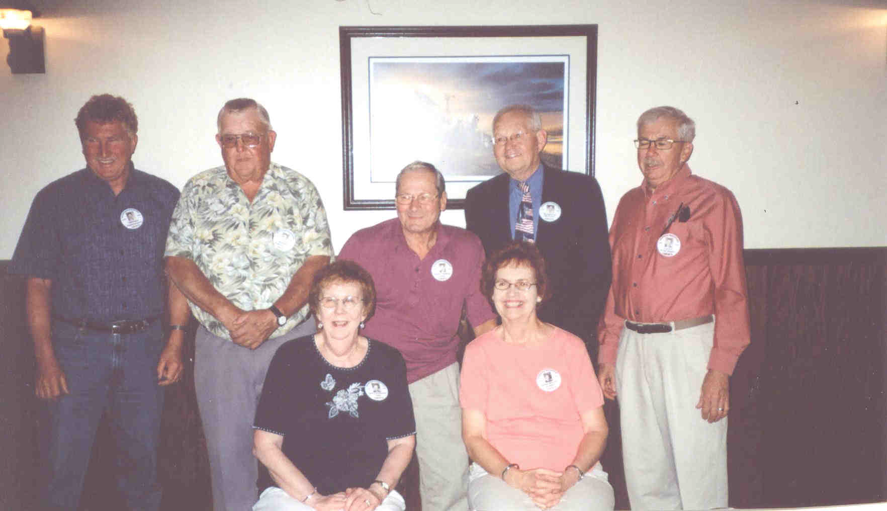
The Mountain High School graduating class of 1959-Taken August 2009

Back Row: William Halldorson, Robert Halldorson
Paul Cox, Eugene Byron
Gardar: Lynn Flanagan
Front Row: Carol Christianson, Darlene Bjornson,

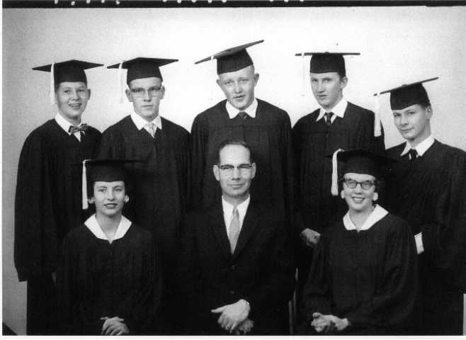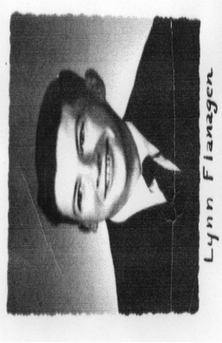
The Mountain High School graduating class of 1959

Back Row: Eugene Byron, Eugene Johnson,
Robert Halldorson, William Halldorson,
Paul Cox.
Front Row: Darlene Bjornson,
Supt. Glenn Lian, Carol Christianson.
Gardar: Lynn Flanagan

The Mountain-Gardar High School classes of 1959 held their 50 year class reunion the week-end of July 31st-August 2nd, 2009. Mountain graduates attending the reunion were: Eugene Byron, Paul Cox, Robert Halldorson, William Halldorson, Carol Christianson Timian, and Darlene Bjornson Knutson. Unable to attend was Eugene Johnson. Gardar graduate Lynn Flanagan was the lone member of his class attending and a time of remembrance was held for his classmates Walter Flanagan, Dennis Page and Norman Laxdal who have passed away. The class hopes to meet again in two years.

Nelson Gerrard Presentations
Pam (Olafson) Furstenau
Nelson Gerrard wowed his audience with two presentations about the Icelandic immigrants at the 34th Annual Family History Workshop at MSUM held on Sep 26, 2009. Thanks to Nelson for sharing his knowledge and taking time to present at the workshop.
For more information on the October 2, 2010 workshop, go to www.mnstate.edu/heritageed or to the Facebook page: ‘’Family History Workshop’’ or contact Pam Olafson Furstenau. She is a board member on the Heritage Education Commission, the organization that conducts the Family History Workshop each year.

WEBSITE NEWS
Pam (Olafson) Furstenau
Visit the website: www.august2nd.com. The website has continued to grow and change. This is a volunteer project and I am gradually adding more information about the Celebration and our Community History. On the website, you will find lots of information! Check it out - there are 32 Pages including the the event schedule, map, Fjalla Blað past issues, membership information, genealogy and souvenir information, Borg Home, Vikur Church, Gardar, Fjalla, grand marshals, ICA and 2nd of August history, photos, sponsors, contact info and much more!
Because it is a volunteer project, any stories, photos, or information that you would like to share are appreciated. Please send them to me at the following address or bring them to the Genealogy Center during the Celebration weekend. Thank you ! (Takk Fyrir!)
pam@rootstotrees.com; Pam (Olafson) Furstenau, 2749 33 ½ Ave S, Fargo, ND 58104

Be A ‘’FAN’’ of the Deuce
Pam Olafson Furstenau
pam@rootstotrees.com
Deuce of August is on FACEBOOK! Check it out and sign up to get the FAN news and updates.
If you have a Facebook page, find us at ‘’August the Deuce.’’ Let´s try to get more fans! From the Deuce page, click on the words ‘’Suggest to Friends.’’ It is on the left side of the page. It just takes a few minutes and then we can let more people know about this page.
If you do not have a Facebook page, just go to the website, www.facebook.com and follow the information to sign up. Anyone can sign up and it is free. Once you get your own page, search for the Facebook page called ‘’August the Deuce.’’
Facebook is a social network website for sharing photos, videos, information, and sending messages. With a Facebook Page, people can become ‘’FANS’’ of the page. People can interact with each other and write on the Page Wall or participate in a discussion board. If you are a FAN, you are not required to write anything but can read the activities on the Page. Other FANS will not see your personal page information unless you agree to be their Facebook friend.
If you have any questions, contact Pam Olafson Furstenau or Darren Olafson.

A Laugh a Day…..
There are history books out there that will tell you the story of the Icelandic immigrants coming to North Dakota to start a new life. The Pioneer Daughter Stories are an amazing collection of stories of the settlement from the point of view of our immigrant grandmothers. But there are stories that will never make it into history books, but give a look into the daily life of our ancestors and show how humor carried them through the good times and the bad and made the days go better. These stories need to be told and retold so that they are not lost to time. Do you have a story you would like to share?

2010- $1000 & $500 Raffle Tickets well be available in June thru August 1st
Drawing will be held after the Tractor pull, August 1st
Contact Duane or Jeanne Halldorson-701-993-8116--halldor3@polarcomm.com

Editors Note
I am sorry to say that the paragraph below in italics is no longer possible for the ICA to maintain. We have been sending out Newsletters to our members and anyone that asked for one since the year 2000. Due to the rising cost of all materials and Postal rates and revisions we are going to have to limit the Newsletters for now to only Members and Contributors. If you hear of anyone that is wondering why they did not get a Newsletter this time please convey our apologies and this message to them.

I would like to remind you that if you have any friends you think might enjoy getting this newsletter have them drop us a line with their mailing address or e-mail address and a brief note on how they heard about us.

Please feel free to contact us at any time at the Icelandic Communities Assoc., PO Box 063, Mountain, ND 58262-0063, Phone# 701-993-8268 - E-Mail (august2@polarcomm.com) - Fax,(701-993-8239) Also, don’t forget to check out our Web Page (www.august2nd.com) for up to date information on our Celebration plans and other activities.

Góða nótt!

